GAS LEAKAGE SENSOR

## A MINI-PROJECT REPORT

***Submitted by***

**KANIMOZHI A 210701104**

**KAVIPRIYA B 210701115**

**LAKSHASRI D P 210701128**

***in partial fulfilment of the award of the degree***

***of***

# BACHELOR OF ENGINEERING

**IN**

**COMPUTER SCIENCE AND ENGINEERING RAJALAKSHMI ENGINEERING COLLEGE, CHENNAI**



**RAJALAKSHMI ENGINEERING COLLEGE, CHENNAI**

**An Autonomous Institute**

# CHENNAI APRIL 2024

## BONAFIDE CERTIFICATE

Certified that this project **“GAS LEAKAGE SENSOR**” is the bonafide work of “**KANIMOZHI A(210701104), KAVIPRIYA B(210701115) and LAKSHASRI D P(210701128)”** who carried out the project work under my supervision.

|  |  |
| --- | --- |
| **SIGNATURE** | **SIGNATURE** |
| **Dr. P. Kumar,**  **HEAD OF THE DEPARTMENT,** | **Dr.N. Duraimurugan, M,E., Ph.D.** |
| Professor and Head, | Academic Head, Associate Professor, |
| Computer Science & Engineering | Computer Science & Engineering |
| Rajalakshmi Engineering College(Autonomous) | Rajalakshmi Engineering College (Autonomous) |
| Thandalam, Chennai -602105. | Thandalam, Chennai -602105. |

Submitted for the **ANNA UNIVERSITY** practical examination Mini-Project work viva voce held on _

**INTERNAL EXAMINER EXTERNAL EXAMINER**

## ACKNOWLEDGEMENT

We express our sincere thanks to our beloved and honourable chairman **MR. S. MEGANATHAN** and the chairperson **DR. M. THANGAM MEGANATHAN** for their timely support and encouragement.

We are greatly indebted to our respected and honourable principal **Dr. S.N. MURUGESAN** for his able support and guidance.

No words of gratitude will suffice for the unquestioning support extended to us by our head of the department **Dr. P. Kumar** for being ever supporting forceduring our project work.

We also extend our sincere and hearty thanks to our internal guide **Dr.N.Duraimurugan,M.E., Ph.D** for his valuable guidance and motivation during the completion of this project. Our sincere thanks to our family members, friends and other staff members of information technology.

## TABLE OF CONTENTS

**CHAPTER NO. PAGE**

## TITLE

ABSTRACT 7

1. INTRODUCTION 8
   1. INTRODUCTION 8
   2. SCOPE OF THE WORK 8
   3. PROBLEM STATEMENT 8
   4. AIM AND OBJECTIVES OF THE PROJECT 8
2. LITERATURE SURVEY 9
3. SYSTEM SPECIFICATIONS 10
   1. HARDWARE SPECIFICATIONS FOR APPLICATION 10
   2. SOFTWARE SPECIFICATIONS FOR APPLICATION 10
   3. HARDWARE SPECIFICATIONS FOR PROTOTYPE 10
4. MODULE DESCRIPTION 11
5. SYSTEM DESIGN 12
   1. ARCHITECTURE DIAGRAM 12
   2. CIRCUIT DIAGRAM 13
6. SAMPLE CODING 14
7. SCREEN SHOTS 16
8. CONCLUSION AND FUTURE ENHANCEMENT 17

**REFERENCES**

## LIST OF FIGURES

|  |  |  |
| --- | --- | --- |
| **FIGURE NO** | **FIGURE NAME** | **PAGE NO.** |
| 5.1 | ARCHITECTURE DIGRAM | 12 |
| 5.2 | CIRCUIT DIAGRAM | 13 |
| 7.1 | CONNECTION | 16 |

**LIST OF ABBREVIATION**

|  |  |
| --- | --- |
| **ABBREVIATION** | **ACCRONYM** |
| **MQ-4** | Methane gas sensor |
| **LCD** | Liquid Crystal Display |
| **I2C - Module** | Inter Integrated Circuit |
| **LED** | Light Emitting Diode |

# ABSTRACT

The issue of the day The compressed gas system leaks cost the world industrial energy. There is an increasing need for dependable and reasonably priced gas leak detection systems due to the increased emphasis on energy efficiency and indoor air quality. particularly in two-wheelers or automobile wheels. We are introducing the creation of an air leakage sensor intended for Internet of Things (IoT) use. The suggested sensor uses IoT technology to track air leaks in vehicles, bicycles, and gas stations, giving users access to real-time data. Upon detection of a breach, the sensor transmits a signal to a central hub, which subsequently sets off an alert and notifies the homeowner through email or a smartphone application. Real-time monitoring and remote access are features of the system that give homeowners increased security and tranquility of mind. The suggested Internet of Things (IoT)-based gas leak detection system for home security applications is proven to be reliable and effective based on experimental results.

**INT****RODUCTION**

## INTRODUCTION

The project “GAS LEAKAGE SENSOR” Significant improvements in vehicle security and safety have resulted from the incorporation of Internet of Things (IoT) technologies. Tire pressure monitoring, which guarantees ideal tire performance and lowers the possibility of accidents brought on by underinflated tires, is a crucial component of vehicle safety. This introduction describes the drawbacks of the current tire pressure monitoring systems, emphasizes the significance of real-time air leak detection in vehicle wheels, and presents the suggested Internet of Things-based solution.

## SCOPE OF WORK

Developing an Internet of Things system to track gas levels and find leaks. choosing the right sensors to detect different gases, such as carbon monoxide, propane, and methane. constructing the connectivity system to send sensor data to the cloud. Provide the IoT system with continuing support and maintenance.

* 1. **PROBLEM STATEMENT**

A gas leak is a serious risk to people's lives and property. Conventional gas leak detection systems frequently don't have real-time monitoring capabilities and don't send out notifications on time, which can be dangerous. To ensure early detection, fast reaction, and potential accident prevention, an Internet of Things (IoT)-based gas leak detection and monitoring system is therefore required.

**1.4 AIM AND OBJECTIVES OF THE PROJECT**

Our project aims to develop a Gas leakage detection using Arduino and creating a system architecture based on the Internet of Things to gather, process, and send data from gas sensors to a centralized platform. Creating software for Internet of Things devices to allow data transfer and sensor communication. ensuring that gas detection systems follow to all applicable safety standards and laws. Applying safety measures in place to guard against false alarms and ensure system dependability.

## LITERATURE SURVEY

[1] The focus of this study was societal issues. One of the biggest problems in society is air leakage in wheel-related accidents. The purpose of this project is to build a gas detection product that uses an alcohol sensor MQ4 sensor to detect hydrocarbon gas. By measuring the amount of gas present in the air, it can identify gas. In order to increase the utility of the gas leakage detector, a circuit with an alarm system is installed on the prototype to alert users in the event of a gas leak. Additionally, the GSM modem is activated, allowing the owner of the mobile number to get an alert message. This prototype has a faster gas sensing and is far less expensive than other items on the market.

[2] The project objective is to construct a completely functional prototype that can detect gas leaks; in this case, though, we planned to utilize air. Furthermore, the prototype should react automatically by activating the GSM modem and an alert system, which will activate the exhaust fan and try to lessen the gas level. A key component of this research is detecting leakage, which is made possible by the sensor capacity to gauge gas concentration. When the gas level is true, a signal is sent to the alarm system to activate.

[3] The application of Internet of Things (IoT) sensors to mitigate interior fire threats in smart buildings has garnered increasing attention in recent years. This study looked on the possible use of IoT sensors in indoor fire hazard contingency by conducting a systematic assessment of 54 articles from interdisciplinary databases over the previous ten years using certain keywords. Twenty-four sub-themes and five major themes—including vision-based sensing, smart automation, evacuation and indoor navigation, early fire detection, intervention and prevention, and BIM-related—were found through thematic analysis. The review findings show that there are several aspects of indoor fire dangers where IoT sensor utilization could be advantageous.

[4] After a protracted ten years, technology is evolving at a swift pace. In order to measure and show the amount of gasoline in a gas cylinder and to facilitate the automatic booking of new gas cylinders, this article presents a wide-area application of the Internet of Things to gas booking. This is accomplished through the use of an integrated gas sensor. Up until recently, a weight machine has been used to assess gas level. However, in this case, a transducer-developed i-sensor (integrated sensor) is used to monitor the level. After connecting to the NODE MCU to read the output, it is Internet of Things (IoT) monitored. It is designed to be installed on cylinders, measuring the fuel level and automatically alerting the connected distributor to refill the cylinder via Internet of Things and a registered gas booking number

[5] The growth of machine learning and the Internet of Things (IoT) has increased interest in flexible gas sensing. In this article, we describe the development of a foldable, flexible, high-performance hydrogen (H2) sensor on any textile substrate using reduced graphene oxide (GO) inkjet printing, and its use in wearable environmental monitoring. The benefits of inkjet printing include cost-effectiveness, non-contact patterning capability, and compatibility with a wide range of substrates. Palladium (Pd) nanoparticles (NPs) have a catalytic impact on wide bandgap GO, making it easy for nonpolar H2 molecules to adsorb and desorb. This effect is the basis of the sensing mechanism.

[6] Because of its demanding operating conditions, the gas monitoring sensor is prone to failure, and identifying the type of fault is challenging. This paper proposes a novel sensor failure detection approach for gas leakage monitoring, based on the Probabilistic Neural Network (PNN) and Naive Bayes Classifier (NBC). First, the aberrant safety monitoring data is found using NBC. Next, PNN is used to classify sensor faults. This method's viability and efficacy are confirmed by using it with the urban gas pipeline leakage monitoring system. It is demonstrated that the type of sensor defect can be accurately identified and that anomalous monitoring data may be differentiated online. It is possible to achieve 85% and 95% global accuracy for aberrant data detection and sensor malfunction diagnosis, respectively.

[7] Fueled mostly by hydrocarbons like propane and butane, liquefied petroleum gas (LPG) is a flammable gas that is regarded as a clean energy source. Due to leaks, the widespread use of LPG as fuel in automobiles, homes, and industries has resulted in a number of catastrophes and fatalities worldwide. Therefore, it is essential to detect LPG correctly. To do this, gas-sensing instruments that can quickly and precisely monitor this gas at room temperature are needed.

[8] Growing numbers of people living in cities as a result of immigration and more pleasant living conditions have created megacities out of once self-sufficient traditional cities and brought up a number of new environmental issues. The old urban view of these issues is inadequate to address the needs of the contemporary population. The idea of a "smart city" emerged from using science and technology to address the primary issues that cities face. In order to manage the efficient and responsible use of resources and to guarantee a sustainable environment for high welfare/public health, it is now necessary to provide citizen-oriented solutions to urban challenges.

[9] Stretchable substrate, electrode, and sensing material optimization have gained attention as a result of wearable electronics for the Internet of Things (IoT). In particular, wearable gas sensors are useful for tracking dangerous substances in real time. Stable operation under mechanical deformation is necessary for wearable gas sensors. Here, we present strain-insensitive Kirigami-structured gas sensors for NO2 detection that are adorned with functionalized carbon nanotubes (CNTs) made of titanium dioxide (TiO2). The substrate is fashioned like a kirigami to guarantee mechanical stability when stretched.

[10] The incorporation of flexible nanocomposite materials to create lightweight, pleasant, and skin-irritating wearable sensors is the main topic of this chapter. Additionally discussed are a variety of biofluids and exhaled breath vapor that include pertinent biomarkers that can be utilized in wearable sensors to diagnose various illnesses. The ease of incorporating the Internet of Things (IoT) has also caused an increase in the need for next-generation wearable sensing technologies across a range of industries, including the security, defense, and healthcare sectors. The purpose of this chapter is to discuss and examine the recent advancements in flexible wearable gas sensor fabrication technologies. The methods for creating and utilizing flexible wearable gas sensors based on nanocomposite materials, as well as the difficulties associated with current gas sensors and future possibilities for wearable nanocomposite sensors.

# CHAPTER 3

## SYSTEM SPECIFICATIONS

## HARDWARE SPECIFICATIONS FOR APPLICATION

|  |  |  |
| --- | --- | --- |
| Processor | **:** | Pentium IV Or Higher |
| Memory Size | **:** | 256 GB (Minimum) |
| HDD | **:** | 40 GB (Minimum) |

## SOFTWARE SPECIFICATIONS

Operating System **:** WINDOWS 10 AND PLUS

Application **:** ARDUINO IDE

## HARDWARE COMPONENTS FOR PROTOTYPE

Sensor **:** MQ-4 gas sensor

Board **:** Arduino Uno

Screen **:** 16x2 LCD Display & I2C Module

# CHAPTER 4

## MODULES DESCRIPTION

### Arduino Uno

This is microcontroller setup for the air leakage sensor which acts as the CPU of the whole system. This takes inputs from the Sensors and triggers the actuators.

### MQ4- Sensor

An MQ4 sensor is a type of gas sensor that is specifically designed to detect methane (CH4) and natural gas. It is widely used in gas leakage detection systems for homes and industries.

### 

### LCD Module

This module is used to notify about the volume of gas in the wheel.

### BUZZAR

A buzzer serves as an audible alarm to alert users of a detected gas presence or air leakage. This setup is crucial for ensuring safety in environments where gas leaks can pose significant hazards.

**I2C Module**

This is used as a communication medium between the LCD module and Controller just utilizing 4 pins from the controller whereas to connect LCD directly it needs more pins.

# CHAPTER 5

## SYSTEM DESIGN

## FLOW CHART

A architecture diagram is a type of diagram that represents an algorithm, workflow or process. The architecture shows the steps as boxes of various kinds, and their order by connecting the boxes with arrows. This diagrammatic representation illustrates a solution model to a given problem.

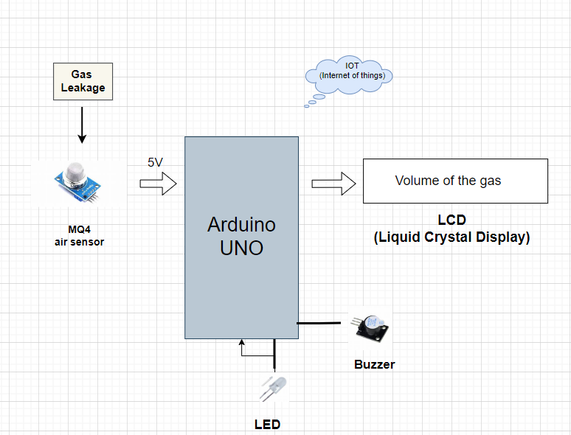

Figure 5.1 Architecture diagram

## CIRCUIT DIAGRAM

The circuit diagram explains the connections made with the hardware components and the board. The Arduino uno is connected with the breadboard as the VCC and GND are connected with the rails. The Sensors, LCD and Servo motor is given connection with the rails and the other input/output pins are connected to digital as per the requirements.

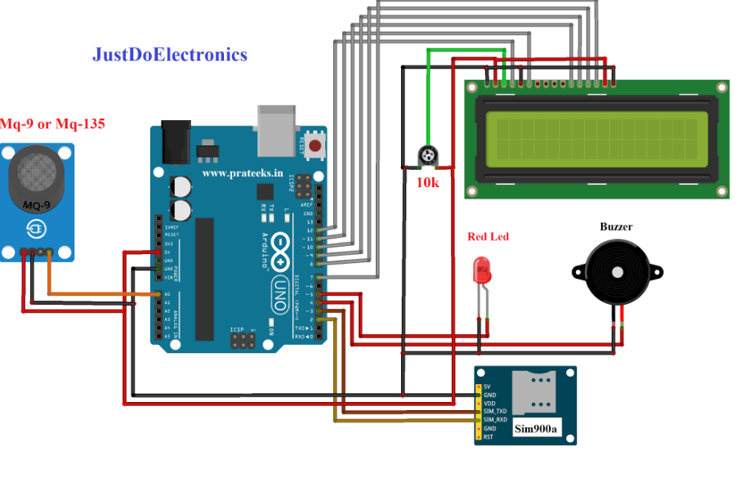

Figure 5.2 Circuit diagram From the above figure 5.2, the connections are made

# CHAPTER 6

## CODING

#include <MQ2.h>

#include <Wire.h>

#include <LiquidCrystal_I2C.h>

LiquidCrystal_I2C lcd(0x27, 16, 2);

int Analog_Input = A0;

int lpg, co, smoke;

MQ2 mq2(Analog_Input);

void setup(){

Serial.begin(9600);

lcd.begin();

lcd.backlight();

mq2.begin();

}

void loop(){

float* values= mq2.read(true);

//lpg = values[0];

lpg = mq2.readLPG();

//co = values[1];

co = mq2.readCO();

//smoke = values[2];

smoke = mq2.readSmoke();

lcd.setCursor(0,0);

lcd.print("LPG:");

lcd.print(lpg);

lcd.print(" CO:");

lcd.print(co);

lcd.setCursor(0,1);

lcd.print("SMOKE:");

lcd.print((smoke*100)/1000000);

lcd.print(" %");

delay(1000);

}

# CHAPTER 7

## SCREEN SHOTS

**CONNECTION**

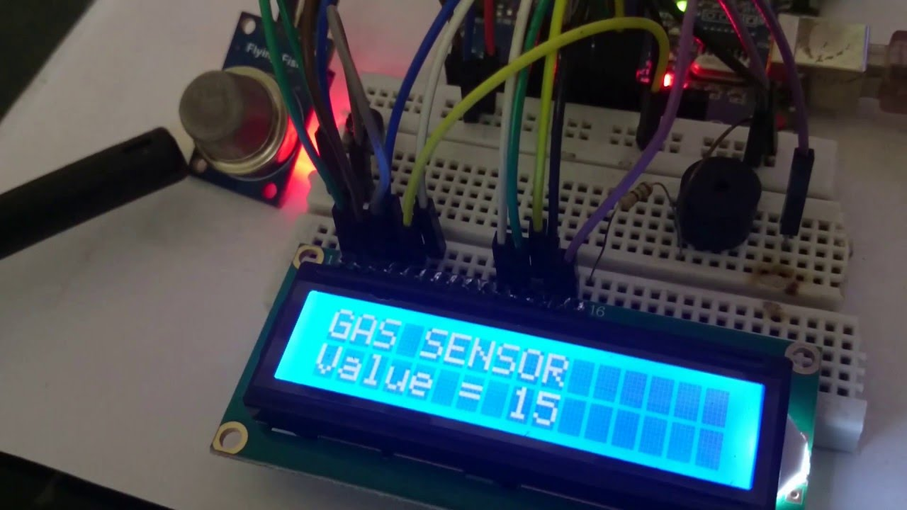

The MQ-4 gas sensor detects methane and natural gas in the air. It operates by changing its resistance based on the concentration of gas it senses. When gas molecules interact with the sensor's surface, the resistance drops, allowing more current to pass through. This change is converted into a corresponding voltage output, which can be read by a microcontroller to determine gas levels. Essentially, the MQ-4 translates gas presence into an electrical signal, enabling real-time monitoring of potential gas leaks.

Figure 7.1 Connection Setup

# 

# CHAPTER 8

## CONCLUSION AND FUTURE ENHANCEMENT

In conclusion, integrating an gas leakage sensor within an IoT framework significantly enhances safety and operational efficiency. These sensors, combined with IoT capabilities, enable real-time monitoring and immediate alerts for gas leaks, crucial for preventing hazardous incidents in residential, commercial, and industrial environments. The use of components like the MQ4 sensor and a buzzer for audible alarms ensures that gas leaks are detected and communicated promptly. IoT connectivity allows for remote monitoring, data logging, and advanced analytics, providing insights into gas leak patterns and system performance. Overall, IoT-enabled air leakage sensors are a pivotal advancement in smart safety systems, offering enhanced protection, convenience, and peace of mind.

Future enhancements for air leakage sensors in IoT will likely focus on improving sensitivity, accuracy, and integration capabilities. Advanced sensor materials and technologies could detect a wider range of gases at lower concentrations. Incorporating AI and machine learning will enable predictive maintenance and anomaly detection, providing preemptive alerts before leaks become critical. Enhanced connectivity options, such as 5G and edge computing, will facilitate faster data processing and real-time decision-making.

# 

# REFERENCES

[1] R. Naresh Naik et al.Arduino Based LPG gas Monitoring &amp; Automatic Cylinder booking with Alert System OSR J. Electron. Commun. Eng. (IOSR-JECE) (2016).

[2] Jena, B., Pradhan, S. K., Jha, R., Goel, S., &amp; Sharma, R. (2023, January 1). LPG gas leakage detection system using IoT. Materials Today: Proceedings. https://doi.org/10.1016/j.matpr.2022.11.172

[3] Shaharuddin, S., Maulud, K. N. A., Rahman, S. A. F. S. A., Ani, A. I. C., &amp; Pradhan, B.(2023, July 1). The role of IoT sensor in smart building context for indoor fire hazard scenario:A systematic review of interdisciplinary articles. Internet of Things. https://doi.org/10.1016/j.iot.2023.100803

[4] Mariselvam, V., &amp; Dharshini, M. (2021, January 1). IoT based level detection of gas for booking management using integrated sensor. Materials Today: Proceedings. https://doi.org/10.1016/j.matpr.2020.05.825

[5] Shaharuddin, S., Maulud, K. N. A., Rahman, S. A. F. S. A., Ani, A. I. C., &amp; Pradhan, B.(2023, July 1). The role of IoT sensor in smart building context for indoor fire hazard scenario:A systematic review of interdisciplinary articles. Internet of Things. <https://doi.org/10.1016/j.iot.2023.100803>

[6]Tan, Q., Mu, X., Fu, M., Yuan, H., Sun, J., Liang, G., & Sun, L. (2022, May 1). *A new sensor fault diagnosis method for gas leakage monitoring based on the naive Bayes and probabilistic neural network classifier*. Measurement. <https://doi.org/10.1016/j.measurement.2022.111037>

[7] Tladi, B., Kroon, R., Swart, H., & Motaung, D. E. (2023, May 1). *A holistic review on the recent trends, advances, and challenges for high-precision room temperature liquefied petroleum gas sensors*. Analytica Chimica Acta. <https://doi.org/10.1016/j.aca.2023.341033>

[8] Salman, M. Y., & Hasar, H. (2023, July 1). *Review on environmental aspects in smart city concept: Water, waste, air pollution and transportation smart applications using IoT techniques*. Sustainable Cities and Society. <https://doi.org/10.1016/j.scs.2023.104567>

[9] Park, J., Lim, H., Yea, J., Ryu, C., Jung, S. I., Jana, R., Jang, K., Keum, H., & Kim, H. J. (2024, March 1). *Kirigami-inspired gas sensors for strain-insensitive operation*. Results in Engineering. <https://doi.org/10.1016/j.rineng.2024.101805>

[10] Motsoeneng, R. G., Tladi, B. C., Swart, H., Kroon, R., & Motaung, D. E. (2024, January 1). *Wearable and flexible nanocomposite-based gas sensors*. Elsevier eBooks. <https://doi.org/10.1016/b978-0-323-95476-1.00009-5>